**Assembly Sec A Lab 4 Fall 2017**

**CONDITIONAL JUMPS**

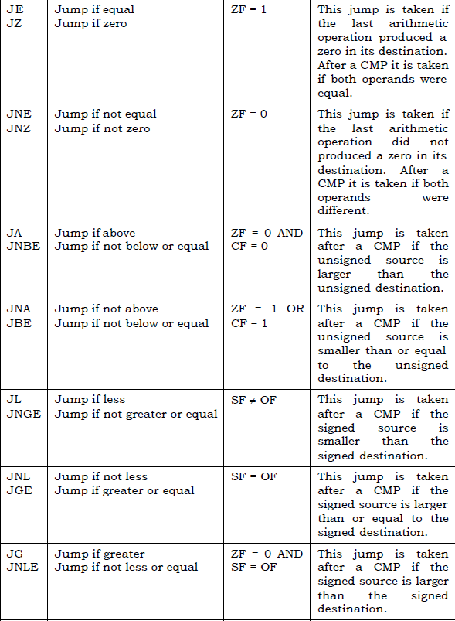

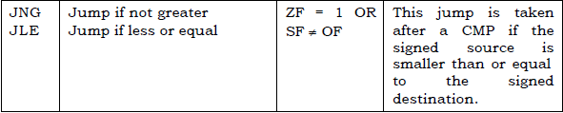

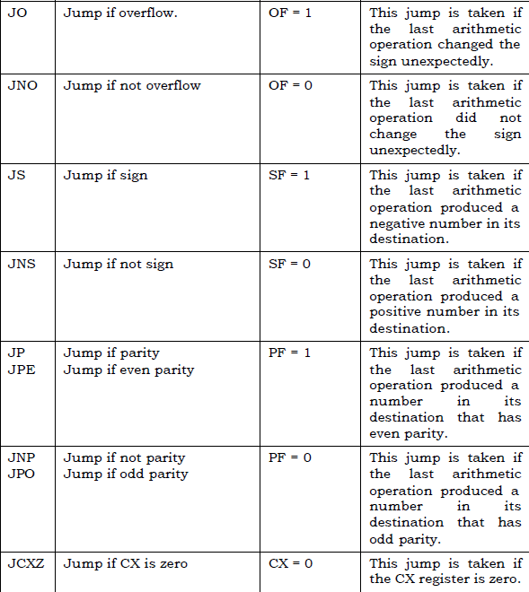

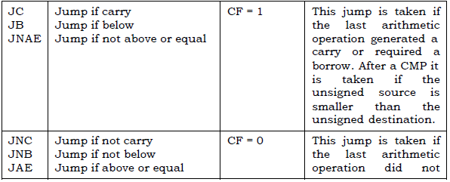

**Example**

|  |
| --- |
| **;; Find Sum of all elements of given array**  [ORG 0x0100]    MOV BX,0  MOV CX,0  L1:  Mov DX, [Array+BX]  Add [Sum], DX    Add BX ,2 ;; +2 in index because of word type array  Add CX,1 ;; counter to maintain size  cmp CX , [Size] ;;; Loop terminating condition  Jne L1  Exit:  MOV AX, 0x4C00 ;  INT 0x21 ; Terminate Program  Array: dw 1,2,5,0,8  Size: dw 5  Sum: dw 0 |

**Problem 1:**

Convert the following C++ code into equivalent assembly code. (The logic in assembly code must mirror the logic in high level code)

Save smallest number in DX instead of output. Don’t consider output statements.

int n1 = 10 , n2 = 5 , n3 = 2;

if((n1 <= n2) && (n1 <= n3)) {

cout << "Smallest: " << n1; // mov DX , [n1]

}

else if ((n2 <= n1) && (n2 <= n3)) {

cout << "Smallest number: " << n2; mov DX , [n2]

}

else {

cout << "Smallest number: " << n3; mov DX , [n3]

}

**Problem 2:**

You are given an array of positive numbers (db type array it means use 8 bit registers for retrieving and comparing a value of memory).Write a program that find an element (Key) in given array. If you find that element than replace that element with sum of array. Otherwise append that element at the end of array.

Example: 3, 5,9,10,99,4,1,3,150,8

Key = 1

After My Program Array = 3, 5, 9,10,99,4,29,3,150,8

Size = 10

**Problem 3:**

Following is code to find most frequent element of an array

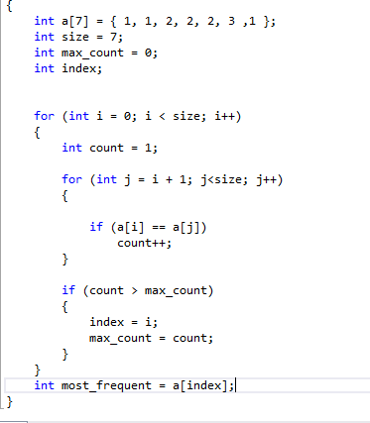

You have to write this code in assembly language

“This is the Book about which there is no doubt, a guidance for those conscious of Allah – **Who believe in the unseen, establish prayer, and spend out of what We have provided for them” (**AL-BAQARAH  2,3**) Think! Where we fall?????**